UNIT3
Lesson14
With MongoDB alone, it’s difficult to keep one saved document consistent with the next. Mongoose offers tools to build models with schemas defining what type of data can be saved.

Use Mongoose (Structured Data)
Example 1: E-commerce Store
You're building an online store. Every product should have:
- Name (required)
- Price (required, must be a number)
- Description
- Category
- Stock quantity
- Images
Why Mongoose? You want to enforce that every product has a name and price. You don't want someone accidentally saving a product without a price, or with the price as text instead of a number. The structure is predictable and consistent.

Example 2: User Registration System
Every user must have:
- Email (required, must be unique and valid format)
- Password (required, hashed)
- Username (required)
- Created date (auto-generated)
Why Mongoose? You need validation - emails must be in proper format, usernames must be unique, passwords must exist. Mongoose handles all this validation automatically.

Use MongoDB Native Driver (Flexible Data)
Example 1: Logging System
You're collecting logs from different parts of your application:
- Error logs might have: {timestamp, error, stackTrace, userId}
- API logs might have: {timestamp, endpoint, method, responseTime}
- User activity logs might have: {timestamp, action, deviceInfo, location}
Why Native Driver? Each log type has completely different properties. Trying to create a schema that fits all of them would be messy. Just store whatever data comes in.

Example 2: Analytics/Events Tracking
You're tracking user events on a website:
- Button click: {event: "click", button: "checkout", timestamp, userId}
- Page view: {event: "pageview", page: "/products", duration, timestamp}
- Purchase: {event: "purchase", items: [...], total, paymentMethod, timestamp}
Why Native Driver? Every event type has different properties. The data is unpredictable and constantly evolving as you add new event types. You just want to dump the data in and analyze it later.

Creating a Schema
A schema is like a class definition in some languages or, more broadly, a blueprint for how you want data to be organized for specific objects in your application. Avoid inconsistent data and specify the structure of your data.

Schema class from mongoose package allows us to create an instance of the class or create a Schema object. With this object/instance we have access to methods from the Schema class like .pre(save) hook and built in validation capabailities.
From the schema object we can create a model (the factory / constructor / builder). We use that model to create new documents based on the schema.

The Flow
- We create models from Mongoose schemas
- We create instances of these models (JavaScript objects in memory)
- We call Mongoose methods like .save() or .create() on them
- Mongoose converts these JavaScript objects into documents
- Mongoose sends them to MongoDB database
- MongoDB stores them in the appropriate collection

Lesson15
Controllers are the glue between your models (the data) and your views (the web page). Now that you have a model set up, you need a controller that handles external requests specifically looking for data related to your model.
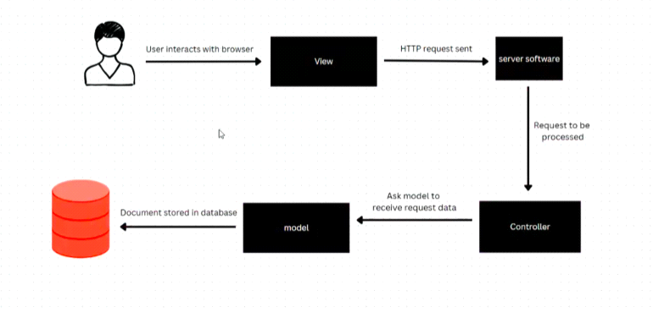

Promises
A Promise is an object that represents a value that isn't available yet, but will be in the future. It's JavaScript's way of saying 'I'm working on this task, and I'll let you know when it's done - either successfully with a result, or unsuccessfully with an error.'"
We use Promises to handle asynchronous operations. Asynchronous operations are tasks that take time to execute. Instead of BLOCKING and waiting, JavaScript continues executing other code. Promises allow us to specify what should happen WHEN the operation completes, without stopping the rest of our program.

With .then():
- Code continues immediately
- Callback executes when Promise resolves

With .catch():
-Handle errors
-Callback executes when Promise is rejected

e.g.
- Request 1: Start database query → continue to next request
- Request 2: Start database query → continue to next request
- Request 3: Start database query → continue to next request
100 requests can be initiated within milliseconds!
Then as each database query completes, send response
Result: Your server can handle 1000+ requests per second

